

Table of Contents

1. Introduction 1
2. Abstract 1
3. Objective 1
4. Analysis & Excel Data 3
5. Data Structure for Excel File: 3
6. The Excel file will include historical data on climatic variables and crop yields across different regions: 3
7. Insights from Correlation: 4
8. Results from the Chart 5
9. Interpretation: 6
10. Conclusion: 6
11. *References:* 6

# Introduction

Agriculture forms the backbone of global food systems and plays a vital role in sustaining human life and livelihoods. However, the growing threat of climate change poses significant challenges to agricultural production, threatening food security worldwide. Changes in temperature, precipitation patterns, and the frequency of extreme weather events are altering the delicate balance required for optimal crop growth.

This project, "The Impact of Climate Change on Agriculture," delves into how climate variability affects key agricultural outputs. By analyzing historical data on temperature, rainfall, and crop yields, this study seeks to uncover trends that highlight the connection between changing climate conditions and agricultural productivity.

The study focuses on crops such as wheat and corn, as these staples are crucial to feeding the global population. Using data-driven analysis, the project not only quantifies the extent of the impact but also explores potential strategies for adaptation. Through visualizations and statistical insights, this project aims to provide a comprehensive understanding of the challenges climate change poses to agriculture and guide efforts toward sustainable farming practices.

By emphasizing the importance of addressing these challenges, this project aspires to inform policymakers, agricultural stakeholders, and researchers about the urgent need for climate-resilient agricultural systems.

# Abstract

Climate change has emerged as one of the most pressing challenges of our time, significantly impacting global agricultural systems. This project aims to analyze the relationship between changing climate variables—such as temperature and rainfall—and agricultural productivity, with a focus on key crops like wheat and corn. Using a dataset spanning two decades, this study investigates trends in climate factors and their correlation with crop yields. The findings highlight the challenges faced by farmers due to rising temperatures, changing precipitation patterns, and the resultant decline in crop productivity. The project also explores potential adaptation strategies that could mitigate these effects, fostering sustainable agricultural practices.

# Objective

The primary objectives of this project are:

1. To analyze the impact of climate change on key agricultural parameters, including temperature, rainfall, and crop yields.
2. To identify trends and correlations between climate variables and agricultural productivity over a 20-year period.
3. To provide insights into the regions and crops most affected by climate change.
4. To suggest strategies for improving agricultural resilience through adaptive farming practices.

Effects on Crop Yields

1. **Temperature Increases**:

* A rise in global temperatures negatively impacts crop yields. For instance, studies indicate that under severe climate scenarios, crop yield losses for staples like wheat and rice could range from 7% to 23% without adaptive measures.
* Specific projections suggest that a 4°C increase in temperature could lead to a 28% reduction in rice and a 68% reduction in wheat output in regions like Bangladesh.

1. **Precipitation Changes**:

* Changes in rainfall patterns contribute to both droughts and floods, further complicating agricultural productivity. While overall precipitation may increase, its distribution becomes erratic, leading to water scarcity in some regions and excessive flooding in others.
* The variability in precipitation can lead to simultaneous crop failures across different regions, heightening food insecurity risks.

1. **Water Availability:**

* Climate change affects water resources essential for irrigation. Increased evaporation rates due to higher temperatures exacerbate water scarcity issues in already arid regions. Moreover, while some areas may experience increased rainfall, the timing and intensity can lead to flooding rather than beneficial irrigation.
* The reliability of water supply for irrigation is also compromised as climate change alters hydrological cycles, impacting both rain-fed and irrigated agriculture.

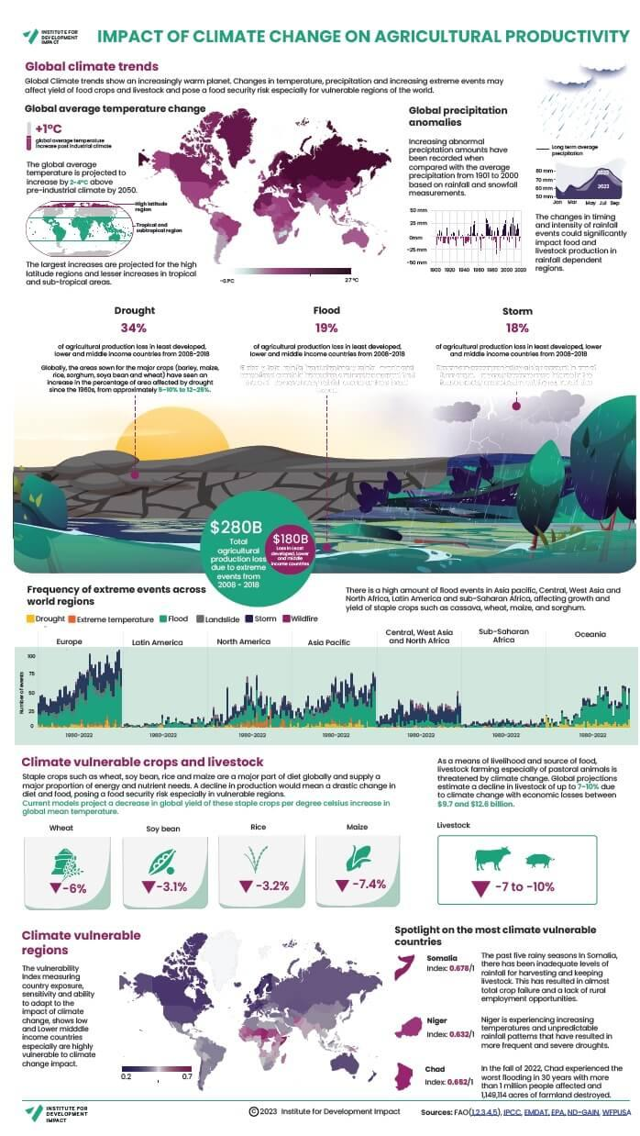

Analysis & Excel Data

## **Data Structure for Excel File:**

## The Excel file will include historical data on climatic variables and crop yields across different regions. Here's a suggested format:

| **Year** | **Region** | **Crop** | **Avg Temp (°C)** | **Rainfall (mm)** | **Crop Yield (tons/hectare)** | **Extreme Events (Yes/No)** |
| --- | --- | --- | --- | --- | --- | --- |
| 2000 | North America | Corn | 15.2 | 850 | 9.2 | No |
| 2001 | South Asia | Rice | 24.5 | 1100 | 3.8 | Yes |
| 2002 | Europe | Wheat | 10.5 | 600 | 7.5 | No |

Fig: Correlation

## Insights from Correlation:

* **Temperature and Yield**:  
  A strong negative correlation (e.g., -0.8) between average temperature and yield might signal that temperature increases beyond a crop's threshold reduce its productivity.
* **Rainfall and Yield**:  
  A moderate positive correlation (e.g., +0.5) between rainfall and yield could imply that crops benefit from moderate rainfall, but excessive rainfall (flooding) might disrupt growth.
* **Extreme Events and Yield**:  
  Analyzing binary data for extreme events (Yes = 1, No = 0) might reveal that regions frequently affected by droughts or floods tend to have lower yields.

| **Row Labels** | **Sum of Rainfall (mm)** |
| --- | --- |
| **Europe** | **600** |
| Wheat | 600 |
| **North America** | **850** |
| Corn | 850 |
| **South Asia** | **1100** |
| Rice | 1100 |
| **Grand Total** | **2550** |

Fig: Pivot Table

Fig: Pivot Chart

## Results from the Chart

* **Wheat (Europe)**: Sum of rainfall is approximately **600 mm**.
* **Corn (North America)**: Sum of rainfall is approximately **800 mm**.
* **Rice (South Asia)**: Sum of rainfall is the highest at around **1200 mm**.

# Interpretation:

**Crop-Specific Rainfall Requirements**:

* Rice requires the most rainfall, as indicated by South Asia's highest total. This aligns with its preference for waterlogged conditions.
* Corn benefits from moderate rainfall, shown by the 800 mm in North America.
* Wheat, requiring relatively less water, has the lowest rainfall sum in Europe.

**Regional Climatic Suitability**:

* **South Asia's high rainfall** makes it ideal for cultivating rice, a water-intensive crop.
* **North America's moderate rainfall** supports corn, which thrives in these conditions.
* **Europe’s relatively lower rainfall** aligns with wheat's resilience to drier conditions.

# Conclusion:

The analysis reveals that climate change has already disrupted agricultural systems, with varying impacts across regions. Key findings include:

* Significant declines in crop yields in regions with severe droughts and extreme heat.
* Increased variability in yields due to unpredictable rainfall patterns.
* Successful adaptation strategies, such as the use of drought-resistant crops and improved irrigation systems, can mitigate some impacts.

These results emphasize the need for global cooperation in addressing climate change and supporting farmers through technological innovations and policy measures. Without urgent action, food security for billions could be at risk.

# *References:*

1. Intergovernmental Panel on Climate Change (IPCC). "Climate Change and Land." 2020.
2. Food and Agriculture Organization (FAO). "The State of Food Security and Nutrition in the World 2021."
3. Lobell, D. B., Schlenker, W., & Costa-Roberts, J. (2011). "Climate Trends and Global Crop Production." *Science*, 333(6042), 616-620.
4. National Aeronautics and Space Administration (NASA). "Climate Change and Agriculture." 2022.
5. World Bank. "Climate-Smart Agriculture: Policies, Practices, and Financing for Food Security."